National University of Computer and Emerging Sciences

## Assignment 01(Part A)

## Saram Khalil

## 21F-9149

## BCS-6B

# Lab Task 1: Build Your First Webpage having your name, roll number, and brief about yourself.

CODE:

<!DOCTYPE html>

<html lang="en">

<head>

    <meta charset="UTF-8">

    <meta name="viewport" content="width=device-width, initial-scale=1.0">

    <title>MyFirst WebPage</title>

</head>

<body>

    <h1>Saram Khalil</h1>

    <h2>21F-9149</h2>

    <p>I am a student of FAST NUCES CFD campus currently studying in th semester. I am good at logic and good with the <b>HTML</b>

    ,<b>CSS</b>,<b>C++</b>,<b>C#</b>and <b>Python</b> as well.</p>

</body>

</html>

OUTPUT:

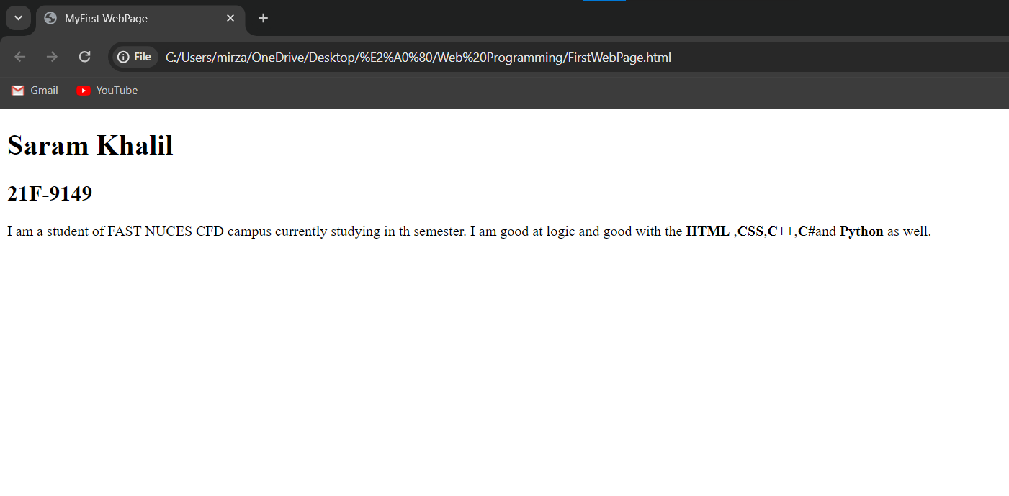

# Lab Task 2: Demonstrate the following output using HTML.

CODE:

<!DOCTYPE html>

<html lang="en">

<head>

    <meta charset="UTF-8">

    <meta name="viewport" content="width=device-width, initial-scale=1.0">

    <title>Task 2</title>

</head>

<body>

    <p><b>This text is bold</b></p>

    <p><strong>This text is strong</strong></p>

    <p><big>This text is big</big></p>

    <p><i>This text is italic</i></p>

    <p>

        <emphasized>This text is emphasized</emphasized>

    </p>

    <p>This is computer output</p>

    <p>This is <sub>subscript</sub>and <sup>supersctrip</sup></p>

</body>

</html>

OUTPUT:

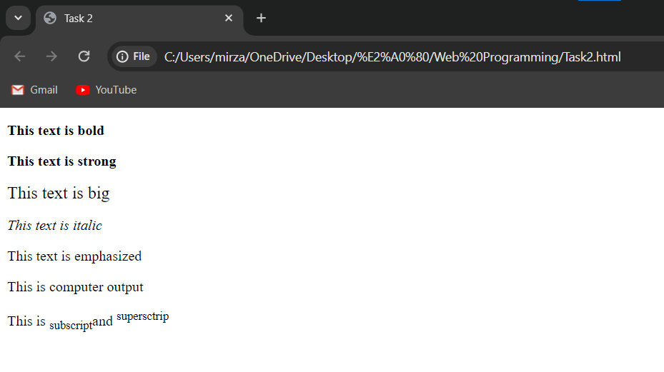

# Lab Task 3: Download the Logo of FAST-NU form Google and display on your webpage in 1000 by 1000 dimension.

CODE:

<!DOCTYPE html>

<html lang="en">

<head>

    <meta charset="UTF-8">

    <meta name="viewport" content="width=device-width, initial-scale=1.0">

    <title>Task 3</title>

</head>

<body>

    <img height="100" width="100" src="FastLogo.png" alt="Fast Logo">

</body>

</html>

OUTPUT:

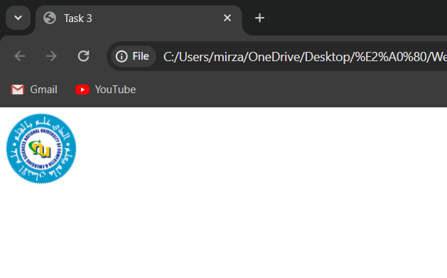

# Lab Task 4: Make the FAST-NU Logo link to fast website and website should be open in new tab.

CODE:

<!DOCTYPE html>

<html lang="en">

<head>

    <meta charset="UTF-8">

    <meta name="viewport" content="width=device-width, initial-scale=1.0">

    <title>Task 3</title>

</head>

<body>

    <a target="_blank" href="https://www.google.com/url?sa=t&rct=j&q=&esrc=s&source=web&cd=&cad=rja&uact=8&ved=2ahUKEwjb96WC-IGEAxXlVKQEHcd0CzcQFnoECCEQAQ&url=https%3A%2F%2Fcfd.nu.edu.pk%2F&usg=AOvVaw3EIOW2aVFbWCb8bSqcH2oB&opi=89978449">

        <img height="100" width="100" src="FastLogo.png" alt="Fast Logo">

    </a>

</body>

</html>

OUTPUT:

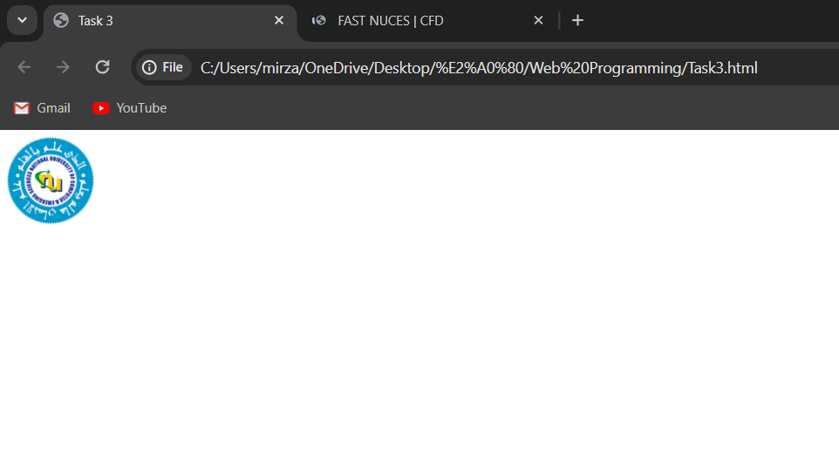

# Lab Task 5: Develop the following webpage using following output.

CODE:

<!DOCTYPE html>

<html lang="en">

<head>

    <meta charset="UTF-8">

    <meta name="viewport" content="width=device-width, initial-scale=1.0">

    <title>Task 5</title>

</head>

<body>

    <h1>HTML Lists</h1>

    <h2>Unordered List</h2>

    <P>We have books on a variety of languages</P>

    <ul>

        <li>Oracle</li>

        <li>java</li>

        <li>HTML</li>

        <li>CSS</li>

    </ul>

    <h2>Ordered List</h2>

    <p>Follow these steps to install java</p>

    <ol>

        <li>Download the software</li>

        <li>Extract to a folder</li>

        <li>Double click the executable to run</li>

    </ol>

</body>

</html>

OUTPUT:

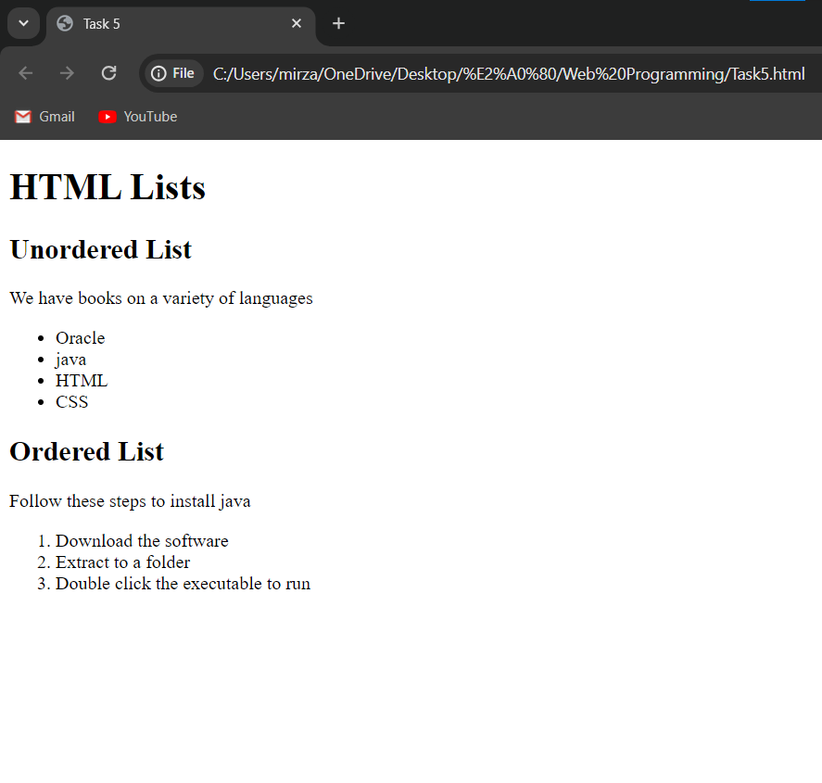

# Lab Task 6: Draw the following table on your webpage.

CODE:

<!DOCTYPE html>

<html lang="en">

<head>

    <meta charset="UTF-8">

    <meta name="viewport" content="width=<device-width>, initial-scale=1.0">

    <title>Task 6</title>

</head>

<body>

    <table border="1px" style="border-collapse: collapse;">

        <tr>

        <th rowspan="3">APRIL</th>

        <th>&nbsp; &nbsp;&nbsp;&nbsp;&nbsp;&nbsp;&nbsp;&nbsp;&nbsp;&nbsp;&nbsp;</th>

        <th>&nbsp; &nbsp;&nbsp;&nbsp;&nbsp;&nbsp;&nbsp;&nbsp;&nbsp;&nbsp;&nbsp;</th>

         </tr>

         <tr>

            <td>&nbsp; &nbsp;&nbsp;&nbsp;&nbsp;&nbsp;&nbsp;&nbsp;&nbsp;&nbsp;&nbsp;</td>

           <td>&nbsp; &nbsp;&nbsp;&nbsp;&nbsp;&nbsp;&nbsp;&nbsp;&nbsp;&nbsp;&nbsp;</td>

        </tr>

         <tr>

            <td>&nbsp; &nbsp;&nbsp;&nbsp;&nbsp;&nbsp;&nbsp;&nbsp;&nbsp;&nbsp;&nbsp;</td>

            <td>&nbsp; &nbsp;&nbsp;&nbsp;&nbsp;&nbsp;&nbsp;&nbsp;&nbsp;&nbsp;&nbsp;</td>

         </tr>

         <tr>

            <td>&nbsp; &nbsp;&nbsp;&nbsp;&nbsp;&nbsp;&nbsp;&nbsp;&nbsp;&nbsp;&nbsp;</td>

            <td>&nbsp; &nbsp;&nbsp;&nbsp;&nbsp;&nbsp;&nbsp;&nbsp;&nbsp;&nbsp;&nbsp;</td>

            <td>&nbsp; &nbsp;&nbsp;&nbsp;&nbsp;&nbsp;&nbsp;&nbsp;&nbsp;&nbsp;&nbsp;</td>

        </tr>

        <tr>

            <td>&nbsp; &nbsp;&nbsp;&nbsp;&nbsp;&nbsp;&nbsp;&nbsp;&nbsp;&nbsp;&nbsp;</td>

            <td>&nbsp; &nbsp;&nbsp;&nbsp;&nbsp;&nbsp;&nbsp;&nbsp;&nbsp;&nbsp;&nbsp;</td>

            <td>&nbsp; &nbsp;&nbsp;&nbsp;&nbsp;&nbsp;&nbsp;&nbsp;&nbsp;&nbsp;&nbsp;</td>

        </tr>

    </table>

</body>

</html>

OUTPUT:

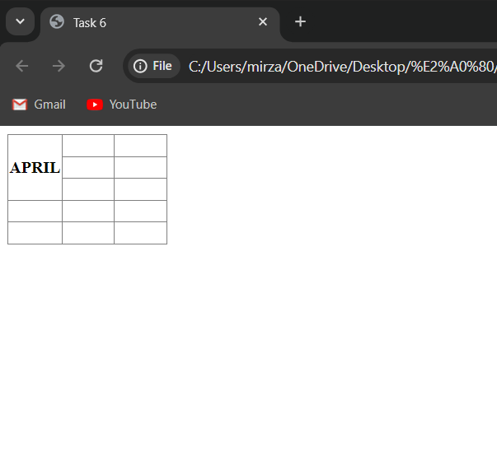

# Lab Task 7: Draw the following table on your webpage.

CODE:

<!DOCTYPE html>

<html lang="en">

<head>

    <meta charset="UTF-8">

    <meta name="viewport" content="width=device-width, initial-scale=1.0">

    <title>Task 7</title>

</head>

<body>

    <table border="1" style="border-collapse: collapse;">

        <tr>

            <th colspan="3">2022</th>

        </tr>

        <tr>

            <td>&nbsp; &nbsp;&nbsp;&nbsp;&nbsp;&nbsp;&nbsp;&nbsp;&nbsp;&nbsp;</td>

            <td>&nbsp; &nbsp;&nbsp;&nbsp;&nbsp;&nbsp;&nbsp;&nbsp;&nbsp;&nbsp;</td>

            <td>&nbsp; &nbsp;&nbsp;&nbsp;&nbsp;&nbsp;&nbsp;&nbsp;&nbsp;&nbsp;</td>

        </tr>

        <tr>

            <th colspan="2" rowspan="2">FIESTA</th>

            <td>&nbsp; &nbsp;&nbsp;&nbsp;&nbsp;&nbsp;&nbsp;&nbsp;&nbsp;&nbsp;</td>

        </tr>

        <tr>

            <td>&nbsp; &nbsp;&nbsp;&nbsp;&nbsp;&nbsp;&nbsp;&nbsp;&nbsp;&nbsp;</td>

        </tr>

        <tr>

            <td>&nbsp; &nbsp;&nbsp;&nbsp;&nbsp;&nbsp;&nbsp;&nbsp;&nbsp;&nbsp;</td>

            <td>&nbsp; &nbsp;&nbsp;&nbsp;&nbsp;&nbsp;&nbsp;&nbsp;&nbsp;&nbsp;</td>

            <td>&nbsp; &nbsp;&nbsp;&nbsp;&nbsp;&nbsp;&nbsp;&nbsp;&nbsp;&nbsp;</td>

        </tr>

    </table>

</body>

</html>

OUTPUT:

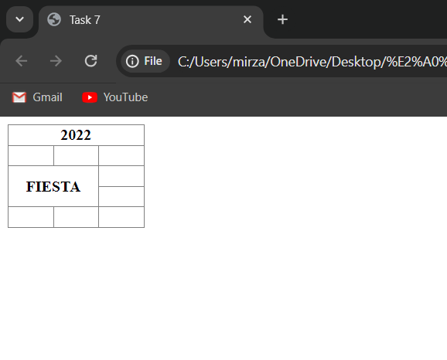

# Lab Task 8: Create a sign-up form on your webpage must including Input Fields (User Name, Email, Password, Confirm Password), Button (Submit, Reset).

CODE:

<!DOCTYPE html>

<html lang="en">

<head>

    <meta charset="UTF-8">

    <meta name="viewport" content="width=device-width, initial-scale=1.0">

    <title>Task 6</title>

</head>

<body>

    <form style="width: 400px; margin: auto;">

        <div style="margin-bottom: 10px;">

          <label for="Username">Username:</label>

          <input type="text" id="Username" placeholder="Enter your username" style="width: 100%;" required>

        </div>

        <div style="margin-bottom: 10px;">

          <label for="Email">Email:</label>

          <input type="email" id="Email" placeholder="Enter your email address" style="width: 100%;" required>

        </div>

        <div style="margin-bottom: 10px;">

          <label for="PASSWORD">Password:</label>

          <input type="password" id="PASSWORD" placeholder="Enter your password" style="width: 100%;" required>

        </div>

        <div style="margin-bottom: 10px;">

          <label for="CONFIRM-PASS">Confirm Password:</label>

          <input type="password" id="CONFIRM-PASS" placeholder="Confirm your password" style="width: 100%;" required>

        </div>

        <div style="text-align: center;">

          <input type="submit" value="Submit" style="padding: 10px 20px; background-color: #000fe8; color: white; ">

          <input type="reset" value="Reset" style="margin-left: 10px; padding: 10px 20px; background-color: #000000; color: white;">

        </div>

      </form>

</body>

</html>

OUTPUT:

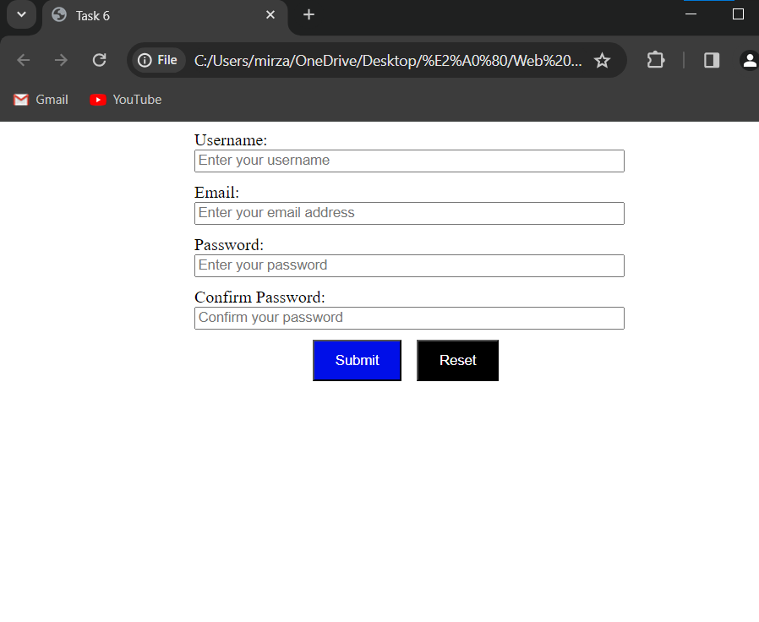

# Lab Task 9: Create the following form using HTML.

CODE:

<!DOCTYPE html>

<html lang="en">

<head>

  <meta charset="UTF-8" />

  <meta name="viewport" content="width=device-width, initial-scale=1.0" />

  <title>Pete's Pizza Delivery</title>

</head>

<body>

  <h1>Pete's Pizza Delivery</h1>

  <h2>Online Order Form</h2>

  <form>

    <label for="user">*Name: </label>

    <input style="margin-left: 26px;"type="text" name="user" id="user" required />

    <label style="margin-left: 54px;" for="tel">*Tel: </label>

    <input type="tel" name="tel" id="tel" required />

    <br />

    <label for="address">*Address: </label>

    <input style="margin-left: 12px;" type="text" name="address" id="address" required />

    <label style="margin-left: 43px;" for="email">Email: </label>

    <input type="email" name="email" id="email" />

    <br />

    <label for="city">*Town/city: </label>

    <input type="text" name="city" id="city" />

    <br />

    <label for="code">*Postcode: </label>

    <input style="margin-left: 7px;" type="text" name="code" id="code" required />

    <p style="text-align: center;">* required fields</p>

    <table>

      <tr>

        <th>Topping</th>

        <th>Size</th>

        <th>Extras</th>

      </tr>

      <tr>

        <td><input type="radio" id="margherita" name="topping" /><label for="margherita">Margherita</label></td>

        <td><input type="radio" id="small" name="size" /><label for="small">Small</label></td>

        <td><input type="radio" id="mushrooms" name="extra" /><label for="mushrooms">Mushrooms</label></td>

      </tr>

      <tr>

        <td><input type="radio" id="margherita" name="topping" /><label for="margherita">Four Seasons</label></td>

        <td><input type="radio" id="small" name="size" /><label for="small">Medium</label></td>

        <td><input type="radio" id="mushrooms" name="extra" /><label for="mushrooms">Green Peppers</label></td>

      </tr>

      <tr>

        <td><input type="radio" id="margherita" name="topping" /><label for="margherita">Meat Feast</label></td>

        <td><input type="radio" id="small" name="size" /><label for="small">Large</label></td>

        <td><input type="radio" id="mushrooms" name="extra" /><label for="mushrooms">Extra Cheese</label></td>

      </tr>

    </table>

    <br><br><br>

    <label for="time">Preferred delivery time: </label>

    <input type="time" name="time" id="time" />

    <br />

    <label for="ins">Delivery instructions: </label>

    <textarea name="instructions" rows="5"></textarea>

    <br />

    <input type="submit" value="Submit order"/>

  </form>

</body>

</html>

OUTPUT:

